Question 3 Notes

Question 3 A
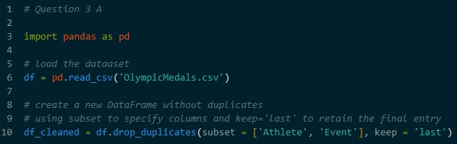
Data Cleaning – Handling Duplicates
- Define a duplicate as any row where the Athlete name and the Event name were identical. This ensures that an athlete isn’t counted twice for the same competition
- Applying the keep=’last’ parameter. This tells the script to look at all matching entries and retain only the final one recorded in the file, deleting the earlier versions
- Implementation : The pandas library function drop_duplicates(subset=[‘Athlete’, ‘Event’], keep=’last’) was used to automate this.

Question 3 B
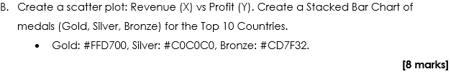
- Aggregation : The script grouped the data by Country and calculated the sum of Gold, Silver, and Bronze medals

- Sorting : Countries were ranked by their total medal count to identify the top 10 performers

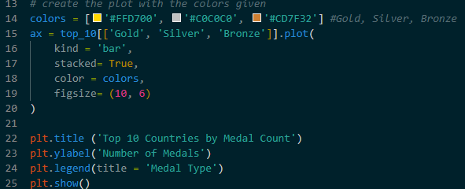
- Specific hex color codes were applied to match the medals :
  - Gold: #FFD700
  - Silver: #C0C0C0
  - Bronze: #CD7F32
- A Stacked format was chosen. In this format, the bars for Gold, Silver and Bronze are placed on top of one another, allowing see both the individual medals types and the total height at once

Question 3 C
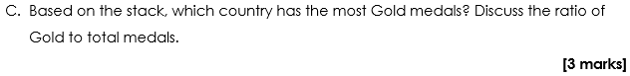
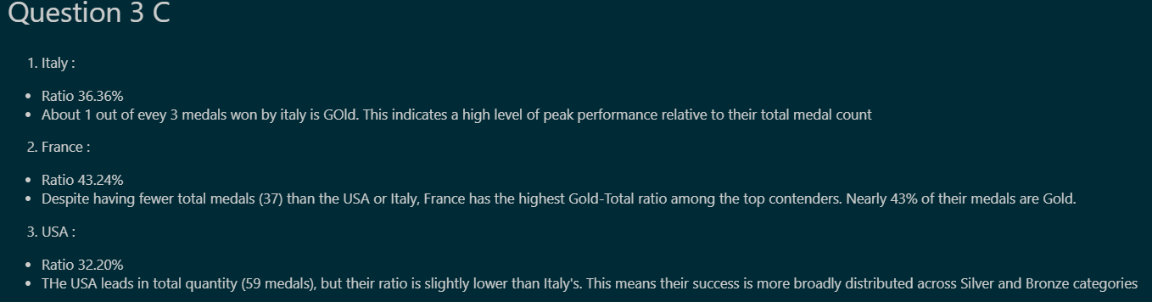
- Italy was identified as the country with the most Gold medals (20), even though it did not have the highest total medal count
- Gold-to-Total Ratio : This calculation is performed by dividing the number of Gold medals by the Total medals won by that country
  - Efficiency – A high ratio (like France 43.24%) indicates that a country is very effective at winning the top prize when they reach a podium
  - Volume – A lower ratio with high total count (like the USA 32.20%) indicates that a country is consistent across all levels of competition but has a more even spread between first, second and third place

